

**AN AI-BASED APPLICANT TRACKING SYSTEM FOR HR**

**BATCH 2021**





Student 1: - Vishaka Pahuja Roll# 023-21-0344

Student 2: - Mohammad Yaqoob Roll# 023-21-0335

Supervisor: Sir Rizwan Abro

TABLE OF CONTENTS

ABSTRACT 4

1.0 INTRODUCTION AND BACKGROUND 4

2.0 PROBLEM STATEMENT 5

3.0 LITERATURE REVIEW 5

4.0 OBJECTIVES 5

5.0 TARGETED USERS 6

6.0 METHODOLOGY 6

6.1 ARCHITECTURE DEVELOPMENT 6

6.2 IMPLEMENTATION 7

6.3 WEBSITE DEVELOPMENT 7

7.0 WORK FLOW CHART 8

7.1 ACTIVITY FOR USER WORKFLOW 8

8

7.2 ACTIVITY FOR HR WORKFLOW 9

9

8.0 TECHNOLOGIES 9

9.0 COSTING 10

10.0 CONCLUSION 10

11.0 REFERENCES 11

# ABSTRACT

The human resource department with in any organization faces problems while recruiting the right candidate for the job. It faces resource shortage, time management and applicant tracking issues for quick and effective hiring process. To resolve such issues and make the hiring process smoother, we have developed an AI-based Applicant Tracking System. The research proposes a 3-stage automated hiring procedure in our Web app for job applications starting with CV scanning via AI-based model to conducting an online test for shortlisted candidates. The system not only ranks the applicant’s resume among several other job opportunities but also takes an online aptitude test for the short-listed candidates based upon the resume’s score. With our proposed model we will try our best to remove biasness and delays in the hiring process and help track the progress of every candidate so as to ensure credibility and accountability of any organization’s HR department. It is concluded that by using AI solutions we can provide better results in less time as compared to man power involvement in the HR department.

# INTRODUCTION AND BACKGROUND

As technology advances, the departments of human resource in industries feel pressure to increase their performance when it comes to the hiring of employees. In the past, hiring activities have been done through resume review, subjective selection, and multiple administrative tasks that lead to long periods of recruitment, increased possibilities of bias, and increased possibility of bias and inconsistency in the selection process. These difficulties are compounded by the volume of application when the organizations grow and receive many applications that it is hard for them to recruit fairly and efficiently. The ability to screen and evaluate applicants through an AI-Based Applicant Tracking System(ATS) come with a solution to these problems. An AI-Based ATS can assess candidates by analyzing their resumes, conducting online aptitude tests, and ranking applicants based on pre-defined criteria. By integrating machine learning(ML) models and natural language processing(NLP), this system is capable of assessing candidates’ skills and experience and decide whether or not they should be invited for the interview and without involving a recruiter at all, thus reducing bias and saving considerable amounts of time for screening. The suggested project aims at the increasing demand for the automatic solutions in the companies’ HR departments, that causes high recruitment volumes, both for the large companies that need to solve a wide range of tasks in recruitment and for the companies that want to optimize their work in this sphere. With the help of this ATS solution, the HR teams will retain the highest levels of transparency and accountability and simultaneously disengage from spending time on routine tasks.

# 2.0 PROBLEM STATEMENT

Current traditional methods of candidate sourcing are disadvantageous in that they are time consuming, prone to bias and hence leads to operational costs, delays and low diversity. Manual resume screening, taking up to seven minutes per resume, hinders HR teams from processing large volumes of applications efficiently. An AI-Based Applicant Tracking System (ATS) eliminates these issues through automated processes involving applicant filtering, testing and ranking. This improves efficiency, reduces bias, and helps organizations optimize talent acquisition while focusing on strategic HR contributions.

# 3.0 LITERATURE REVIEW

Forced recruitment simplification and elimination of bias are the major reasons behind the development of ATS and AI tools. Most of yesterday’s ATS systems, for example, Workday and Greenhouse, continue to rely on keyword matching, missing out on some qualified talents, and seldom assessing actual competencies (Burns, 2021). Robust systems, for instance, HireVue and Pymetrics utilize AI and NLP besides identifying resumes and behavioral evaluations but have higher tendencies of reproducing biases influenced by datasets (Zhao et al., 2020). While including more recent neuro-techniques such as LSTM and BERT, resume parsing and the consideration of context is enhanced depending on the format and comparison (Zhang & Johnson, 2019). We identified that metrics and skill-based suggestions provided by LinkedIn Recruiter do not reflect specificity for each position, which provides generic suggestions (Smith & Patel, 2022). Cloud-hosted ATS solve the above problem by enhancing flexibility but at the same time introduce the problem of data protection that has to meet regulatory and legal frameworks such as GDPR, which may be time-consuming (Lee & Kim, 2021).

This underscores the need for ATS solutions that enhance accuracy, reduce biases, offer personalization, and ensure strong security.

# 4.0 OBJECTIVES

* **Automate CV Analysis:** Employ the AI parsing methods to work through the data of CVs in the shortest possible time with a least human interference and achieve maximum accuracy.
* **Conduct Candidate Assessments:** Provide possibilities for online testing to evaluate such candidates with regard to the necessary skills and competencies through such tests.
* **Streamline the Recruiter and Candidate Experience:** Make better interaction designs that enables easy tracking of applications and working on reviews that will enhance the employers’ hiring system.

# 5.0 TARGETED USERS

* **HR Professionals**: Recruiters and hiring managers streamline tasks like resume screening, candidate assessments, and decision-making.
* **Job Applicants**: Access a transparent hiring process, track applications, and complete assessments efficiently.
* **Organizational Management**: HR directors and business owners benefit from improved hiring metrics and reduced bias.
* **IT Teams**: Ensure smooth system integration and data security.
* **Industries**: Medium to large enterprises, startups, and educational institutions seeking efficient recruitment solutions.

## 6.0 METHODOLOGY

The approach used to design and implement the AI-Based Applicant Tracking System (ATS) involves the architectural approach, implementation approach and web application approach. This methodology focuses on the development of a strong architecture or framework that enhances the flow of data and communication between the components with incentive towards the accommodation of future modifications. The implementation phase focuses on developing AI models for CV scanning, predictive analytics, and integration with existing HR systems, followed by testing and fine-tuning. The web application development process involves defining specific features and designing an intuitive user interface for real-time monitoring of applicant data, predictive insights, and management of the hiring process. In summary, the methodology is intended to present the straightforward approach for hiring away special talent, minimize bias during talent selection, and provide the datasets useful for the HR departments to make informative decisions.

.

## 6.1 ARCHITECTURE DEVELOPMENT

* + 1. **System Architecture Design:**
       - 1. Technology Selection: Choose appropriate technologies, frameworks, and AI models (e.g., Natural Language Processing, Decision Trees) based on project requirements.
         2. Integration Plan: Develop a comprehensive plan for integrating the ATS with existing HR systems and databases to ensure seamless data exchange and process automation.
    2. **Data Source Identification:**
       - 1. Identify Data Sources: Determine the various sources of applicant data, including resumes, application forms, and assessments.
         2. Data Collection: Implement processes to gather data from these sources for analysis and model training.
    3. **System Configuration:**
       - 1. Database Design: Design a database schema to store applicant information, resumes, and related metadata efficiently.
         2. User Role Management: Establish user roles and permissions for HR personnel to manage the hiring process securely.

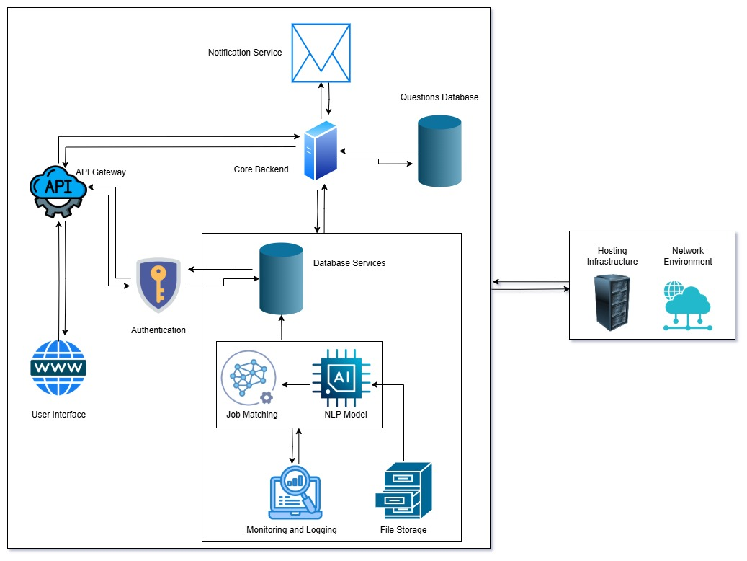

## 6.2 IMPLEMENTATION

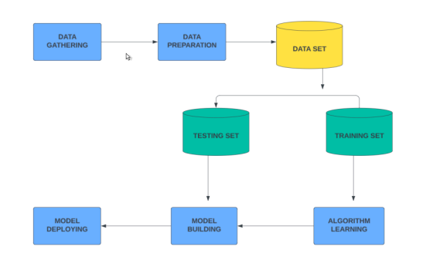

## 6.3 WEBSITE DEVELOPMENT

* + - * 1. Feature Specification: Define the specific functionalities that the website will offer, such as real-time monitoring of applicant status, notifications for new applications, analytics dashboards for HR metrics, and user management features for HR personnel.
        2. User Interface Design: Create an intuitive and visually appealing interface for the website that allows users to navigate easily.
        3. Frontend and Backend Integration: Ensure seamless integration between the frontend and backend systems to facilitate smooth data flow and user interactions.

# 7.0 WORK FLOW CHART

## 7.1 ACTIVITY FOR USER WORKFLOW

## 

## 7.2 ACTIVITY FOR HR WORKFLOW

8.0 TECHNOLOGIES

**Programming Languages:**

* Python: For backend development, machine learning, and NLP.
* JavaScript: For creating a dynamic and interactive front-end.

**Frameworks:**

* Django: Backend framework for routing, APIs, and server-side logic.
* React: Frontend library for building user interfaces.

**Machine Learning and NLP Tools:**

* spaCy: For natural language processing and resume parsing.
* TensorFlow/PyTorch: For training machine learning models.

**Database:**

* MongoDB: A NoSQL database for flexible, schema-less data storage, ideal for handling diverse and dynamic applicant data formats.

9.0 COSTING

|  |  |  |  |  |
| --- | --- | --- | --- | --- |
| | **Category** | **Cost**  **(USD)** | **Cost (PKR)** | **Details** | | --- | --- | --- | --- | |
| |  |  |  |  | | --- | --- | --- | --- | | **Total Budget** | **$1,400** | **392,000** | Focused on open-source tools and cost-effective services. | |
| |  |  |  |  | | --- | --- | --- | --- | | **Cloud Services** | $500 | 140,000 | Use free-tier services (AWS Free Tier or Google Cloud's free credits). | |
| |  |  |  |  | | --- | --- | --- | --- | | **NLP and Machine Learning** | $300 | 84,000 | Utilize open-source libraries like spaCy, TensorFlow, and PyTorch. | |
| |  |  |  |  |  | | --- | --- | --- | --- | --- | | **UI/UX Design Tools** | $400 | 112,000 |  | Leverage free Django and React tools with minimal paid plugins. | |
| |  |  |  |  | | --- | --- | --- | --- | | **Testing and Optimization** | $150 | 42,000 | Use open-source tools like Selenium, PyTest, and free versions of Postman. | |
| |  |  |  |  | | --- | --- | --- | --- | | **Miscellaneous Costs** | $50 | 14,000 | Minor expenses for hardware or unforeseen requirements. | |

10.0 CONCLUSION

The **AI-Based Applicant Tracking System (ATS)** provides the highest level of selection, openness, and equity with the help of CV parsing, analyzing and using data for predictions. In-line with system architecture, AI model formulation and web deployment, ATS enables the HR teams to monitor and evaluate applicants in real-time on an easily navigated platform. This approach not only fast forwards candidate identification and minimizes bias but also optimize overall candidate acquisition results, setting up for further enhancements in the future. The ATS could thus be viewed as useful asset to HR departments as it enhances the role of AI in the hiring process, while also providing the means to ensure greater levels of responsibility for the head of HR departments.

# 11.0 REFERENCES

# 

* Burns, A. (2021) ‘Challenges and limitations of traditional applicant tracking systems’, *Journal of Human Resource Management*, 15(3), pp. 234-242.
* Zhao, X., Tan, M., and Chen, L. (2020) ‘AI in recruitment: The benefits and ethical implications’, *Computers in Human Behavior*, 104, pp. 105-117.
* Raghavan, M., Barocas, S., Kleinberg, J., and Levy, K. (2020) ‘Mitigating bias in algorithmic hiring: Evaluating claims and practices’, *ACM Conference on Fairness, Accountability, and Transparency*, pp. 469-481.
* Zhang, Y. and Johnson, T. (2019) ‘Neural network approaches to CV parsing and candidate matching’, *IEEE Transactions on Human-Machine Systems*, 49(4), pp. 456-463.
* Smith, R. and Patel, N. (2022) ‘Bridging skill gaps: Limitations of skill-based ATS recommendations’, *International Journal of Human Resource Development*, 18(2), pp. 320-335.
* Lee, S. and Kim, J. (2021) ‘Data privacy concerns in cloud-based recruitment systems’, *Information Systems Journal*, 31(1), pp. 123-138.